**‘Delete Pet’ Page-** This page is where you go to if you wish to delete pet details.

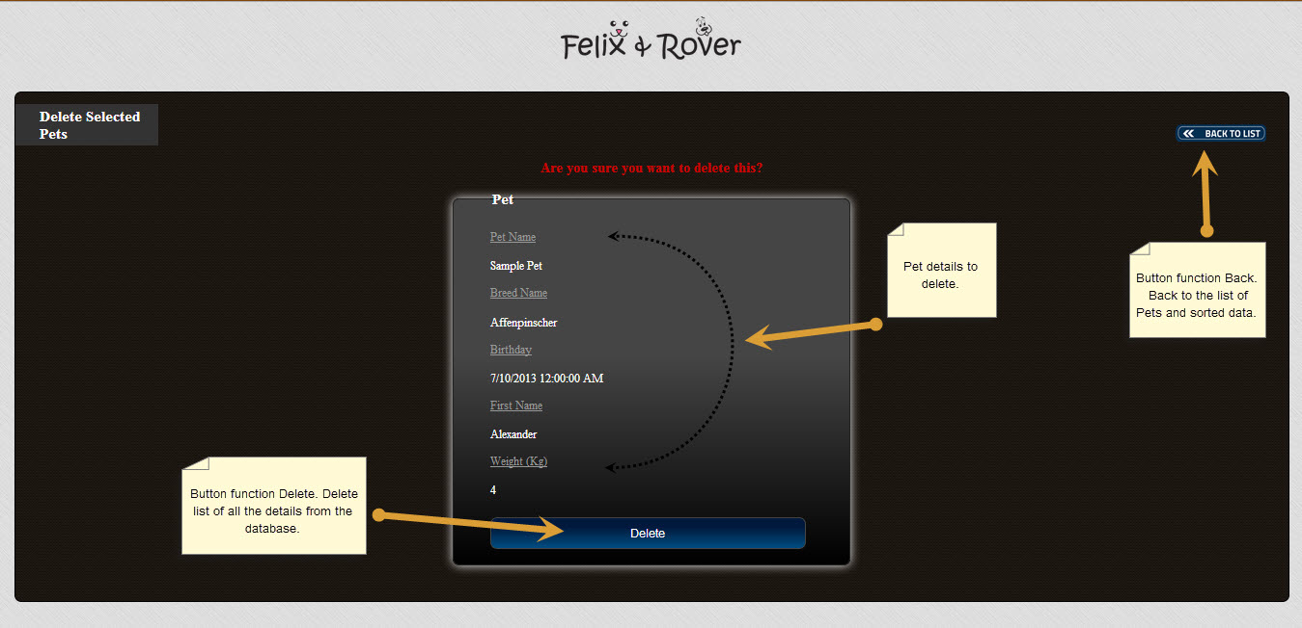

**‘Details of Pet’ Page** – This page allows you to edit details of your pet, such as its name, breed, birthday, its owner’s name and its weight.

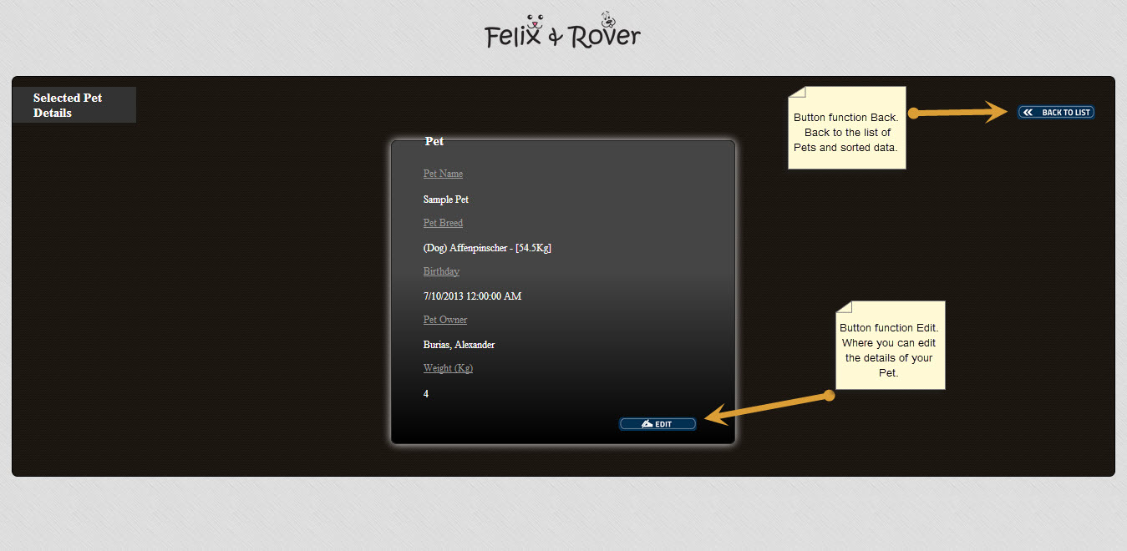

**‘List of Pets’ Page** – This page shows you a detailed list of registered pets. Here, you will see the pet’s name, breed, birthday, owner, weight, and the veterinarian assigned to it. You also have the option to edit or delete pet information, see pet details and enter new pet information.

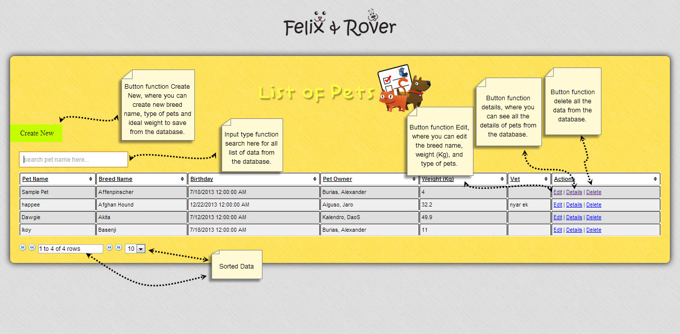

**‘Create New Pet’ Page** – This page is where you enter details of your new pet, such as its name, breed, birthday, its owner’s name and its weight.

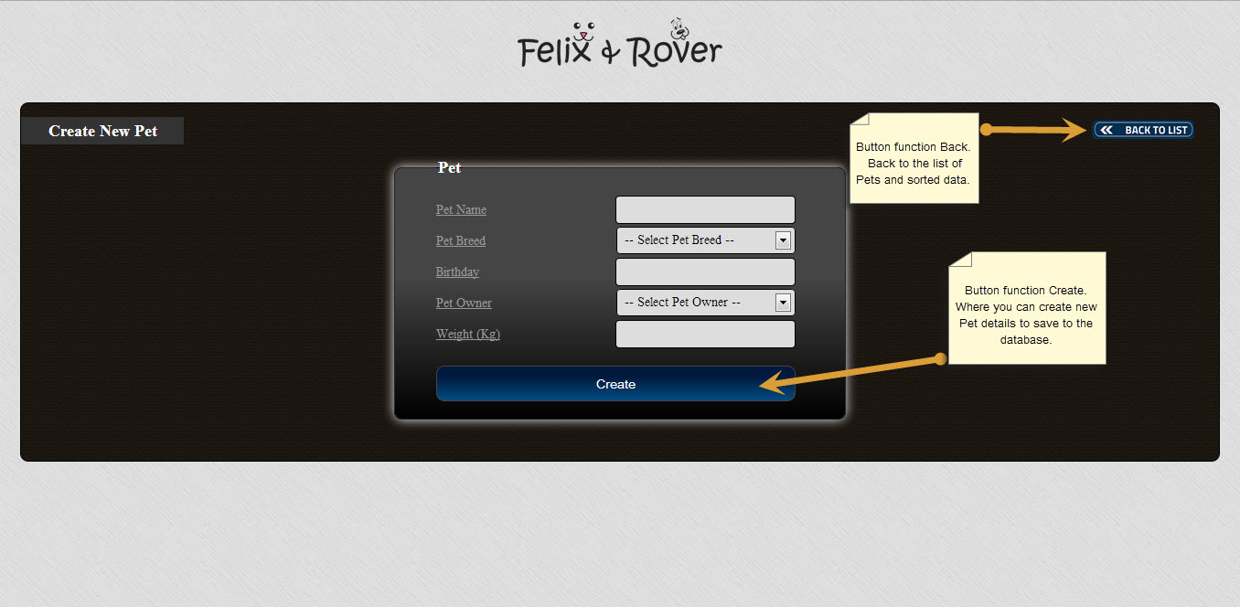

**‘Update Selected Pet’ Page** – This page is where you can update pet details if you wish to make changes to its name, breed, birthday, owner, or weight.

